September 6th, 2018

**UPDATES ON LAB MAPPING USING LabEQIP**

*Summary by Elive Ngale (GHSC-PSM) on behalf of the team of those trained*

**Overview**

* Genesis of LabEQIP
* Background and Purpose
* Features
* Usefulness
* Where are we today?
* Where do we want to go?
* Discussion

1. **Genesis**

* Development of Sample Transport Network Optimization Tool: LLamasoft (2013)

1. **Background**

* **Implementing Partners:** USAID, CDC, GHSC-PSM, LLamasoft
* **Conceptualization pilot:** Ethiopia 2013
* **Methodology approach:** 2014, Partner discussions begin (QII components added to model)
* **Development:** Began in early 2015
* **Deployment:**  2016 Mozambique and Rwanda roll out

**2016 Regional training in Uganda**

* Cameroon present at training (NPHL, NACC, PEPFAR (GHSC-PSM), CHAI, EGPAF)

1. **Purpose of the tool (data visualization)**

* **Current Situation**
* Lab network data are not stored centrally or analyzed in a holistic manner
* EQA testing is performed, but there is no mechanism to consolidate and analyze results over time
* GIS data can only be assessed using expensive, complicated software by highly trained employees
* Sample collection-to-test site referrals are not very efficient
* Root causes for poor performance cannot be easily identified
* **Solution**
* Create an easy to use, open source tool that can act as a data repository for information relevant to the laboratory network performance
* Link relevant data and provide users with the ability to visualize the system (maps, charts, etc.)
* Provide visibility into performance and resources over time to assess the effect of various interventions
* Provide optimal referral assignments

1. **Tool Details/Features**

**Two major components:**

* Part I: Development of QA/QC monitoring, mapping, reporting and visualization tool
* Part II: Referral network optimization

**Features:**

* Single Database Solution
* GIS Capabilities
* Data Visualization Tools
* Accessible Optimization Solution
* *All open source components
  1. **Part I: Development of QA/QC monitoring, mapping, reporting and visualization tool**

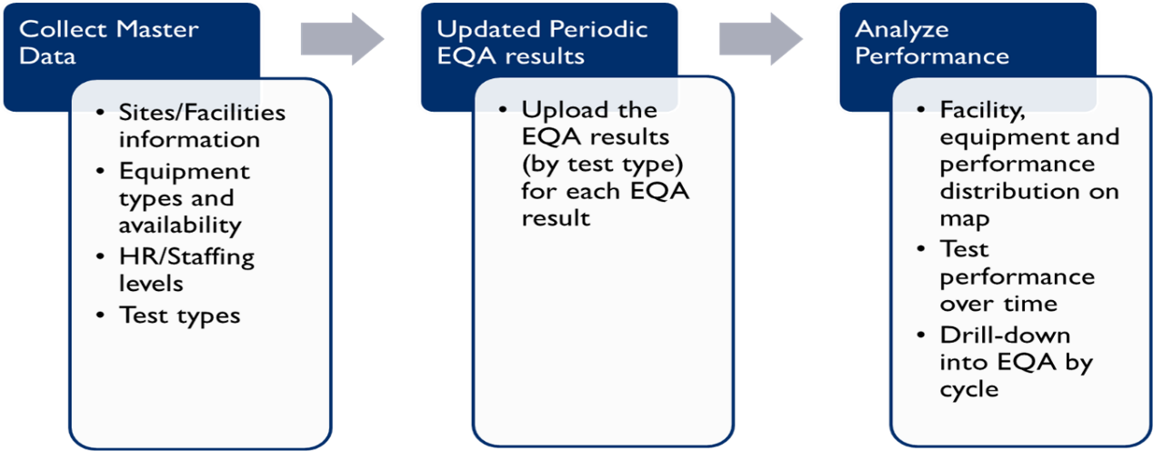

* 1. **Part II: Referral Network Optimization**

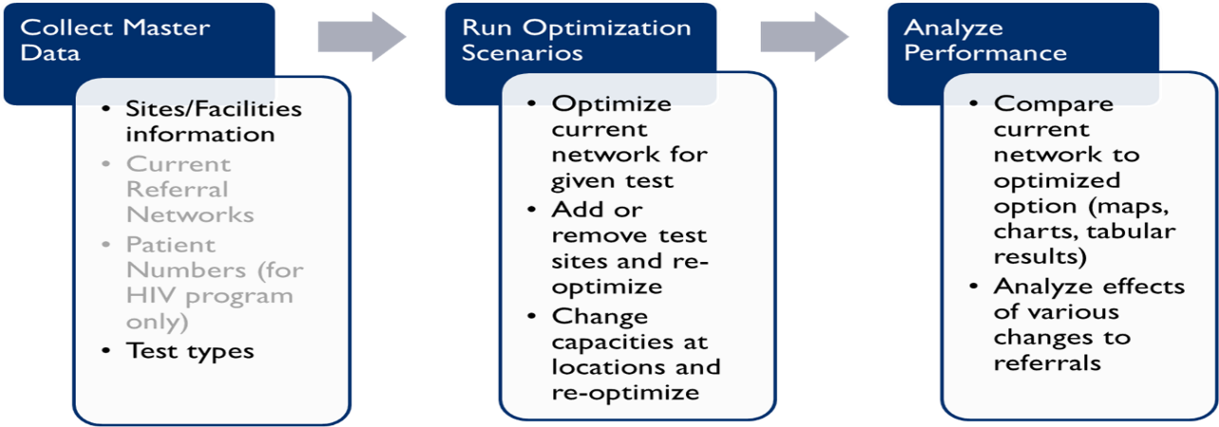

1. **Usefulness/Where can LabEQIP help?**

* Platform location optimization
* POC integration
* Sample transport
* Instrument management
* Staffing – HR
* Quality Assurance
* Geographic prioritization
* Additional logistics considerations

1. **Volume of task needed for mapping and optimization**

|  |  |  |
| --- | --- | --- |
| **Collect Master Data** | **Run Optimization Scenarios** | **Analyze Performance** |
| 80% | 10% | 10% |

1. **Where are we now in Cameroon?**

|  |  |  |
| --- | --- | --- |
| When | Task | Output |
| November 2017 | The team composed of representatives from NPHL, NACC, GHSC-PSM, CHAI, EGPAF, had a planification meeting in November to strategize on how to collect the data and perform the analysis. | NACC and NPHL were tasked to include lab optimization data collection requirements within the scope of WHO’s planned data collection of health facilities, so to avoid duplication of efforts and resources. |
| June 2018 | Workshop on Lab strategic plan organized by DLMEP (sponsored by CHAI/UNICEF) during which update of the draft mapping of August 2017 was also included on the agenda. | Update of Master (see details below) |
| June – April 2018 | Data Compilation and test visualization trials | Availability of geocodes; Successful upload of partially completed data; tentative visuals available from partially completed data *(Summary of output/progress listed below under Collection of Master Data)* |

* **Collection of Master Data**

|  |  |  |  |
| --- | --- | --- | --- |
| **Items needed** | **Sub - activities needed** | **Progress as of August 1st 2018** | **Comment** |
| Facility Type |  | Completed |  |
| Facility Level |  | Completed |  |
| Test Type | * Name * Description * Passing threshold | Completed |  |
| Equipment | * Name * Test type * Daily max throughput | Completed |  |
| Site | * Code |  | Continuous data cleaning as referral linkage is being done |
| * Health Facility name |  |
| * Address | Not done | Poses no challenge to the optimization |
| * City | Completed | Continuous data cleaning as referral linkage section is being done |
| * Administrative district | Completed |
| * Administrative Region | Completed |
| * Administrative zone | Completed |
| * Facility Type | Completed |
| * Facility Level | Completed |
| * Latitude | Completed |
| * Longitude | Completed |
| * Phlebotomist/Health Care Auxiliary * Lab Assistant * Lab Technician * Lab Scientist * Lab QA * Lab Safety * Lab Logistics Manager | <15% completed |  |
| Test sites info | * Site * Test type * Testing days per month/month * Primary equipment | Completed | < 5% of data cleaning remaining |
|  | * Primary Equipment - Serial # * Primary Equipment – MFG Date * Primary Equipment – Installation Date * Secondary Equipment * Secondary Equipment - Serial # * Secondary Equipment – MFG Date * Secondary Equipment – Installation Date * Tertiary Equipment * Tertiary Equipment - Serial # * Tertiary Equipment – MFG Date * Tertiary Equipment – Installation Date |  |  |
| Referral linkage | * Referral site * Test Type * Test site | 40% completed | This will be completed on September 15 while the data cleaning will be completed on September 20. This is the key section to enable a complete visualization and the optimization scenarios |
| Transit time override | * Transit time override | Default time of 24hours; but not yet begun for actual transit time |  |
| Country HR Requirement | * Phlebotomist/Health Care Auxiliary * Lab Assistant * Lab Technician * Lab Scientist * Lab QA * Lab Safety * Lab Logistics Manager | 60% progress in data compilation, but not yet incorporated into Master data | Begun for conventional test sites and EGPAF POC sites |
| Site patient numbers | * Site | Completed from *Test Site Info* |  |
| * Patients on treatment | Data made available by NACC and in the process of being compiled | For now, we cannot ascertain the level of progress until September 15th |
| * Patients on pre-treatment | No longer in the context of Cameroon |  |
| * Pregnant women | Challenge |  |
|  |  |  |  |
|  |  |  |  |

* While the data is being compiled, data visualization (graphs and scenarios) can gradually be plotted. However, this is possible only on a cleaned data set, which must be done before the data can be successfully uploaded and the visuals generated.
* For this, and to make the task more efficient, the team shared out tasks and the following have been done;

|  |  |  |  |  |
| --- | --- | --- | --- | --- |
| **Tasks** | **Taking the lead** | **Verification** | **Notes** | **Coordination** |
| Master Data Compilation | GHSC-PSM | CHAI & EGPAF | Components for the data have been contributed by NACC, GHSC-PSM, CHAI, EGPAF, CIS | NACC/ NPHL/DLMEP |
| Master Data Cleaning | EGPAF | GHSC-PSM & CHAI |
| Visualization from cleaned data | CHAI | GHSC-PSM & EGPAF |

1. **Where are we going?**
2. **Plan**

|  |  |  |
| --- | --- | --- |
| Activity | Timeline | Responsible |
| complete the site referral linkage by September 15th | September 15th | GHSC-PSM |
| compile Site patient numbers *(Patients on treatment & Pregnant women)* in 6 non PEPFAR Regions | September 15th | CHAI |
| compile Site patient numbers *(Patients on treatment & Pregnant women)* in 4 PEPFAR Regions | September 15th | EGPAF |
| Merge and data cleaning | 17th & 18th September | Team |
| Run Optimization scenarios | 19th September | Team |
| Analyze performance | 20th & 21st September | Team |
| Prepare final mapping report | 24th & 25th September | Team |

|  |  |  |
| --- | --- | --- |
| **Dates** | **Working Space/Venue** | **Comment** |
| 17th Sept 2018 | NPHL |  |
| 18th Sept 2018 | GHSC-PSM |  |
| 19th Sept 2018 | CHAI |  |
| 20th Sept 2018 | EGPAF |  |
| 21st Sept 2018 | NACC |  |

**Recommendation**

We will strongly request if EGPAF can permit their staff Mr Tesoh Halyday to work with the team in Yaounde from 17th to 21st September 2018.

1. **Perspectives/Discussion**

* Upon completion of this mapping exercise, we will recommend the NPHL/NACC/DLMEP to organize for the presentation of the complete results
* Organize for the national workshop on mapping in a bid to ensure the necessary needed updates, get effective and operational within the mandate of NPHL especially in view of the larger laboratory network